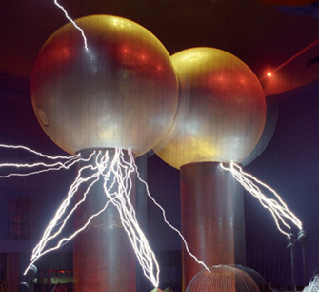

[**VISUAL PHYSICS ONLINE**](http://www.physics.usyd.edu.au/teach_res/hsp/sp/spHome.htm)

**MODULE 4.1**

**ELECTRICITY**

**ELECTROSTATICS**

**CHARGE**

**Think about life without the use of electricity?**

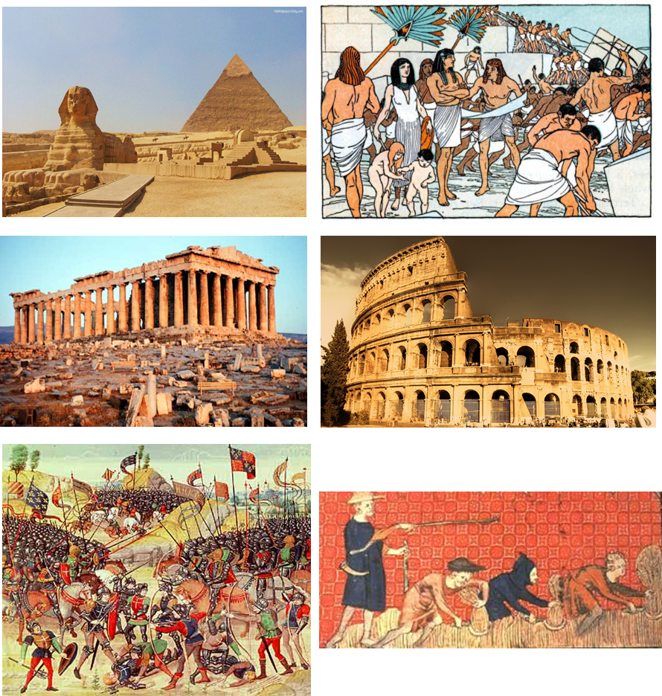

Fig. 1. No electricity in days gone by. **But what is electricity?**

It is worthwhile to do a web search and find out about the life and work of [Michael Faraday](https://www.famousscientists.org/michael-faraday/).

**What is meant by electricity?**

Electricity is the name given to a wide range of electrical phenomena and is associated with everything about us – lightning from the sky; it makes your mobile phone work; it’s in the light by which we can see things; when we sit in a chair, it’s what holds the molecules together; it controls our body functions and thinking. Electricity is not a physical quantity that can be measured, it is just a label.

Look carefully at figure 2. Each picture tells a story. For each individual picture, write a few lines of text, outlining the story behind each picture.

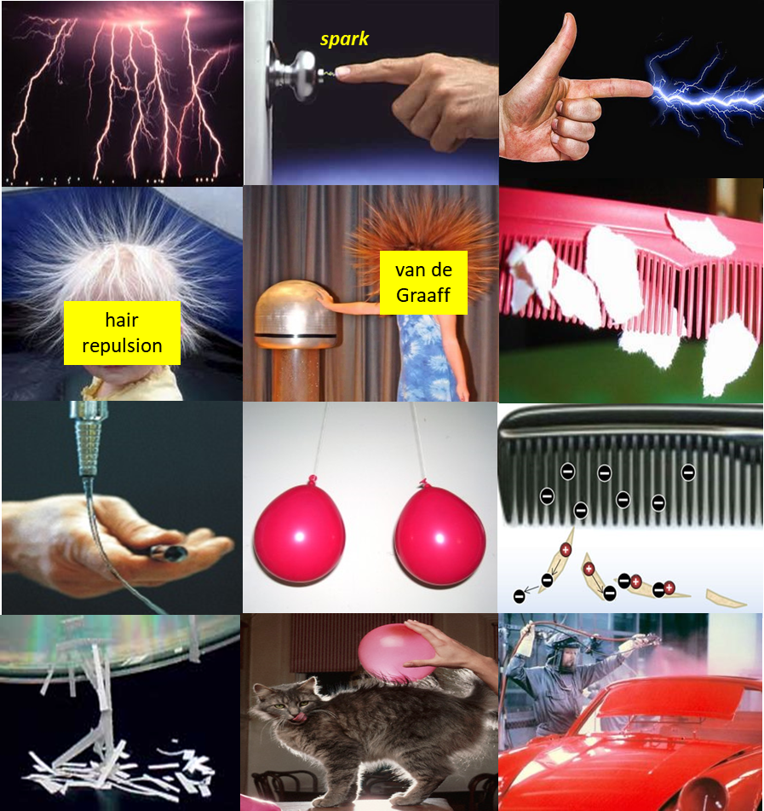

Fig. 2. What does each picture tell you?

An understanding of electricity requires a step-by-step approach: you must clearly understand a concept on which the next step is based. The starting point for the study of electricity is to know about the structure of an **atom** and the concept of **charge**. **Electrostatics** is the study of the behaviour of charges at rest. Electric interactions (forces) arise because of the property of charge.

Before you read the following notes, I suggest you watch the video on **Electric Charge** (Electric Charge: Crash Course Physics #25)

As you watch, create a summary of the information contained in the video.

* List of the electrical quantities.
* State the laws and principles.
* What is meant by a charge?
* What are the types of charges?
* How does an object become charged?
* How do charged objects interact with each other?
* How does a charged object interact with a neutral object?
* Describe the equation for the interaction between point charges?
* What is wrong with the model of the atom displayed?

<https://www.youtube.com/watch?v=TFlVWf8JX4A>

Figure 2 shows many of the effects known as **static electricity** and the forces which act are called **electrostatic forces**. These attractive and repulsive effects arise because objects acquire either a **positive** or **negative** charge. **Charge** is an intrinsic property of the fundamental particles – the **electron** and the **proton**.

* Electrons repel electrons
* Protons repel protons
* Electrons attract protons.

This property, charge, gives rise to electrical forces. By convention, the **electron** is said to be **negatively charged** and the **proton** **positively charged**.

|  |
| --- |
| **Charge**: *q* or *Q*  S.I. unit: coulomb [ C ]  elementary charge *e* = 1.6x10-19 C  1 C = 6.28x1018 electrons  charge on an **electron** **-** *e*  charge of a **proton** + *e* |

All matter is made up of atoms. The atom is composed of the central nucleus containing the positive protons and neutral neutrons. Surrounding the nucleus are the electrons some of which may be located at “great” distances from the nucleus. Normally, the number of protons equals the number of electrons and the atom is **neutral**.

However, some atoms tend to gain electrons to form negative ions (**anions**), while other atoms lose electrons to form positive ions (**cations**). An atom is mostly empty space. The diameter of a nucleus is in the order of 10-15 m, while the diameter of the atom is in the order of 10-10 m. The ratio of the volume of an atom to the volume of the nucleus is a staggering 1015.

A planetary model of an atom is shown in figure 3. But, this model is **WRONG**.

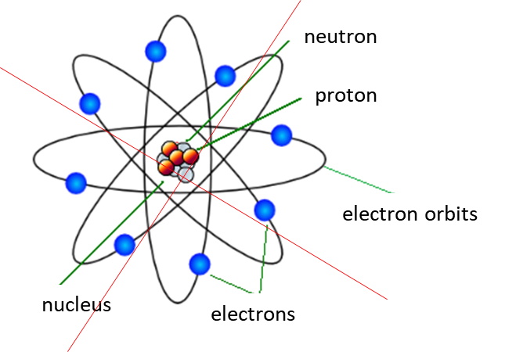

Fig. 3. A planetary model of the atom – this model although often used is **WRONG**. Electrons do not orbit the nucleus.

The best model of the atom we have today is based upon the branch of physics known as Quantum Mechanics. When electrons are confined, they exhibit **wave-like properties**. We know that when a string is fixed at both ends, then only large amplitude vibrations can be excited to give standing wave patterns (stationary nodes and antinode positions) corresponding to the normal modes of vibration at discrete frequencies. The same applies to the electrons in atoms. The electrons act like waves and are confined to the atom, and this results in the states of electrons having definite standing wave patterns. Each standing wave pattern gives information about the probability of locating the electron in a small volume element. There are regions where there is zero probability of finding the electron (nodes) and regions where there are high probabilities of locating electrons (antinodes). The total energy of an electron / atom system is quantized. The total energy does not have a continuous range of values, just like the allowed frequencies of vibration of the string. Figure 4 show [2D] computer generated plots of the probability distribution of finding the electron in a hydrogen atom.

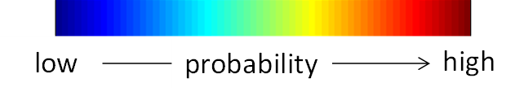f

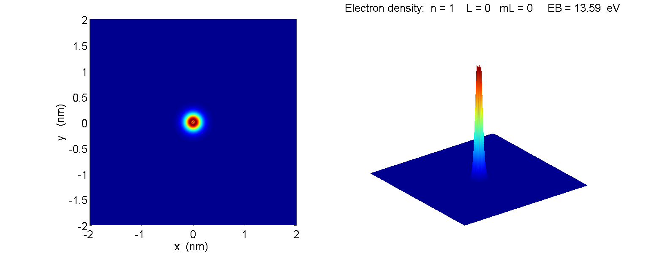

Fig. 4A. The ground (lowest energy) state probability distribution for the electron in a hydrogen atom. Notice that the electron is located close to the nucleus and is tightly bound.

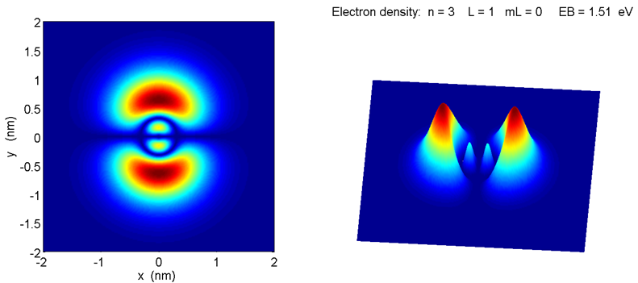

Fig. 4B. A higher energy state of the hydrogen atom. You will notice that there is now a much higher probability of finding the electron at much greater distances from the nucleus, so, the electron is now much easier removed to form the positive hydrogen ion.

Most electrical phenomena is related to the transfer of the outer most electrons to or from atoms. Objects become charged when the atoms that make up the object gain or lose electrons. If the object **gains electrons** it becomes **negatively** charged and if it **loses electron**s it becomes **positively** charged.

For example, when a glass rod is rubbed with a silk cloth, electrons are removed by friction from the glass and transferred to the silk – the glass becomes positively charged and the silk cloth negatively charged. When a wooden rod is rubbed with wool it gains electrons to become negatively charged and the wool becomes positive (figure 5).

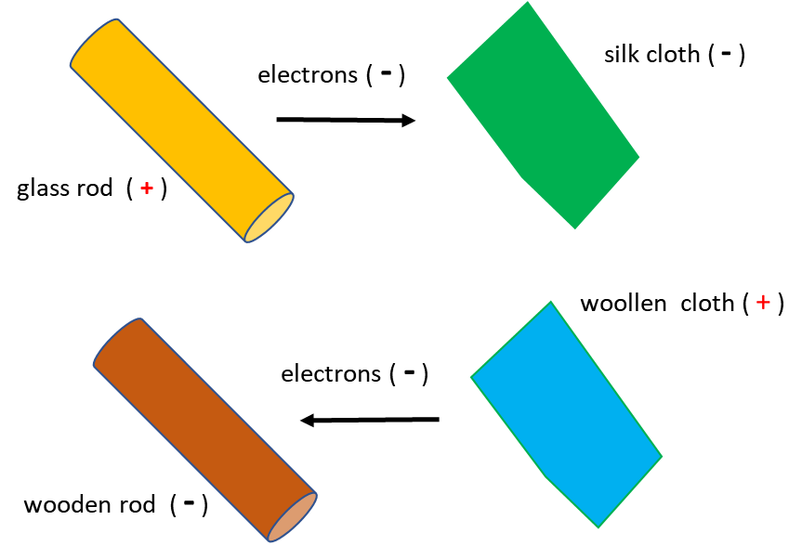

Fig. 5. An object only becomes charged by the transfer of electrons.

Since electrons repel electrons, protons repel protons and electrons attract protons, we can say

**Objects with the same charge repel each other.**

**Objects with the opposite sign attract each other.**

We also find that

**Any charged object can attract a neutral object.**

Charge is a conserved quantity, and this is known as the **principle of charge conservation**. When an object is charged, electrons are simply transferred from one material to another – there is no creation or destruction of charges. This may seem an impressive law.

But, stop and think – this law is truly “mind boggling” – there is no natural event that occurs or any action a of man that can change the net amount of charge in the entire universe that we know of.

But our Universe is even more amazing then this!!! In science fiction books and movies, you hear about antimatter? But, what is antimatter?

We live in a Universe composed of matter particles (e.g. the neutron, proton and electron etc.) All particles have antimatter counterparts. Anti-particles resemble their corresponding particles in every way except for the sign of their charge and the direction of their 'spin'. Examples of three particles and their antimatter counterparts are: the electron and positron; proton and antiproton; neutrino and antineutrino. One of the mysteries of the Universe is why there is any matter at all when it is believed that equal quantities of matter and antimatter were created in the 'Big Bang'.

When an anti-particle meets its corresponding particle the two **annihilate** each other converting their mass to pure energy. These annihilations do not occur in a purely random way however; they must obey three rules: the **conservation of energy**, the **conservation of momentum** and the **conservation of charge**.

For example: consider the annihilation of an electron e- and its antiparticle the positron e+. The combined mass is converted into pure energy in the form of photons. (2 gamma-ray photons are necessary to conserve momentum) and charge. Since the charges cancel at the beginning before the collision there is no net charge at the end either.

The reverse process called **pair production** is also possible. Of course, the possibility of two photons of the right energy meeting to produce an electron/positron pair is negligible. However, a single gamma-ray photon can spontaneously produce such a pair as it passes close to a nucleus, which recoils thus conserving energy and momentum. The only requirement is that the gamma-ray photon carries an energy equivalent to the combined rest masses of the electron and positron. If the incident photon has more energy than this then the excess appears as kinetic energy of the electron/positron pair.

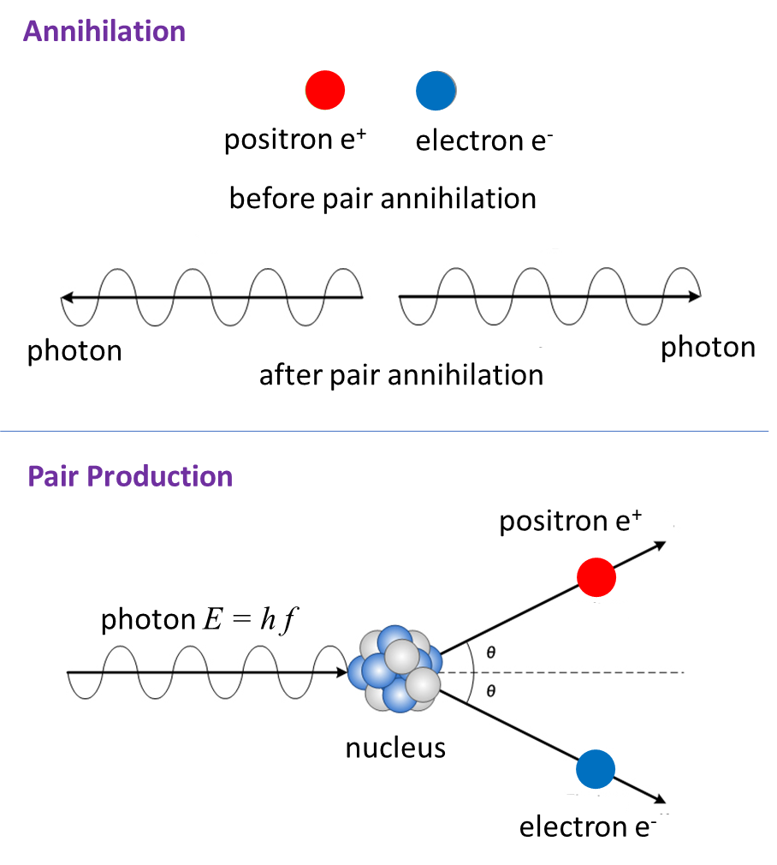

Fig. 6. Electrons can be destroyed or created but only in processes where charge is conserved. In the processes of annihilation and pair production, energy, momentum and charge are conserved.

We charge things by transferring electrons from one place to another. This is done by physical **contact**, where objects are simply touched or rubbed together. Object can also be charged in a process called **induction**.

Sometimes, particularly in dry conditions, you can become charged by walking on carpet, then, when you touch a metal door handle, you are discharged through by the spark between your fingers and the door knob.

An object can be become charged by **induction** without any physical contact. Consider two insulated metal spheres A and   
B in contact with each other. When a positively charged rod is bought near the spheres, the free electrons in the conducting sphere are attracted to the positive rod, the two spheres are still neutral, but the charge has been redistributed, the metal near the positive rod is more negative than the metal further way from the rod. When the two metal spheres are separated with the positive rod still present, the two sphere will now be negatively and positively charge as shown in figure 7.

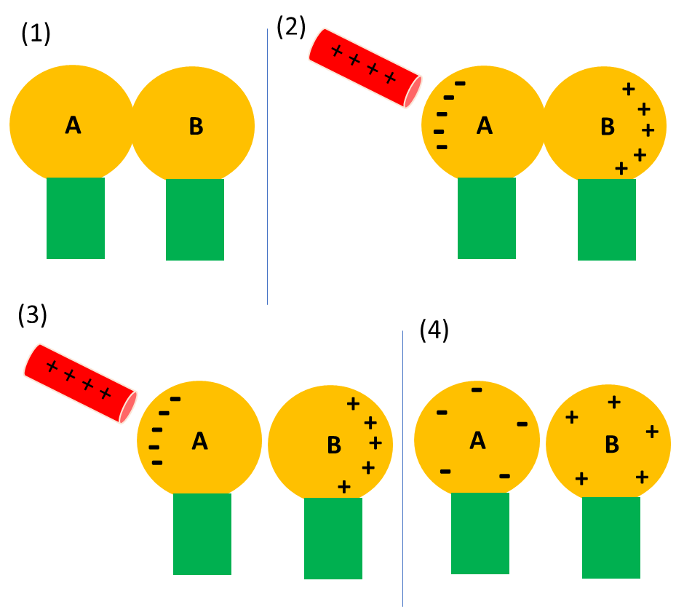

Fig. 7. Charging by induction.

We can also charge a single insulated metal sphere by induction if we touch it when the charge is not uniformly distributed throughout the sphere. Bring a negatively charged rod near the insulated conducting metal sphere as shown in figure 8. Then, if we touch the metal sphere with a finger, we are providing a pathway for electrons to move between the metal sphere and the ground (this is called grounding). We then remove the finger, then the charged rod. The metal sphere will now be positively charged (opposite sign to the rod).

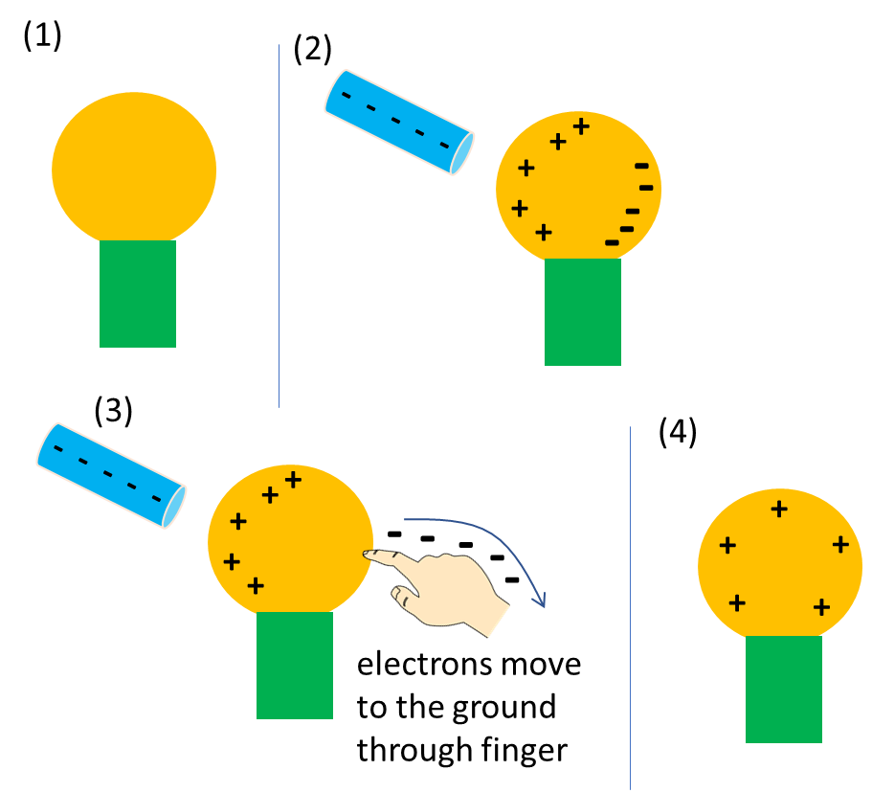

Fig. 8. Charging by induction.

Charging is not restricted to conductors. When a charged rod is bought near an insulator, there are no free electrons to move through the material. However, the electrons within the atoms and molecules can be redistributed – the centre of charge is moved. One side of the atom becomes more negative, while the other side can become more positive (figure 9). The atoms or molecules are now **electrically polarized**.

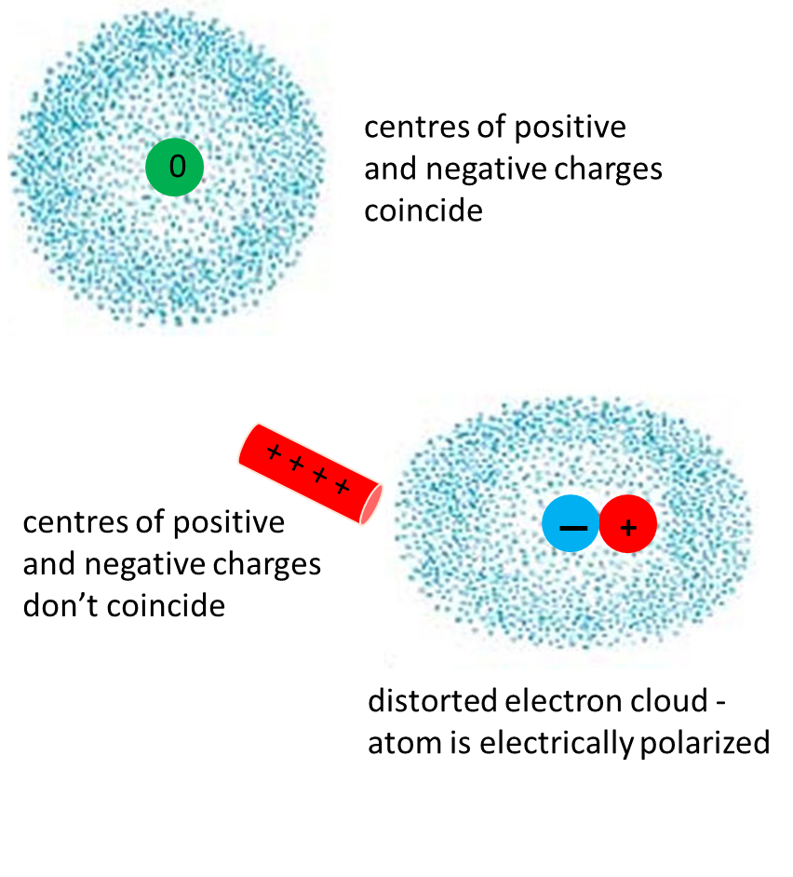

Fig. 9. Electrically polarized atom. Note: there is no change in the position for the centre of positive charge, only the centre of the negative charged cloud is shifted.

**Why is a neutral object attacked to a charged object? Why does a charged balloon stick to a wooden wall?**

By rubbing a balloon with a woollen jumper, it balloon will become negatively charged. When placed against a wooden (insulating surface) the balloon will stick to the wall for a considerable period. The charged balloon induces an opposite change on the wall surface due to the electric polarization of the atoms that make up the wall. The positive polarized charge is nearer to the negative balloon than the induced positive charge, therefore there is a net attractive force between the balloon and the wall, so the balloon sticks (figure 10). Note, the wall remains neutral.



This is the reason that a charged comb can pick up small pieces of paper.

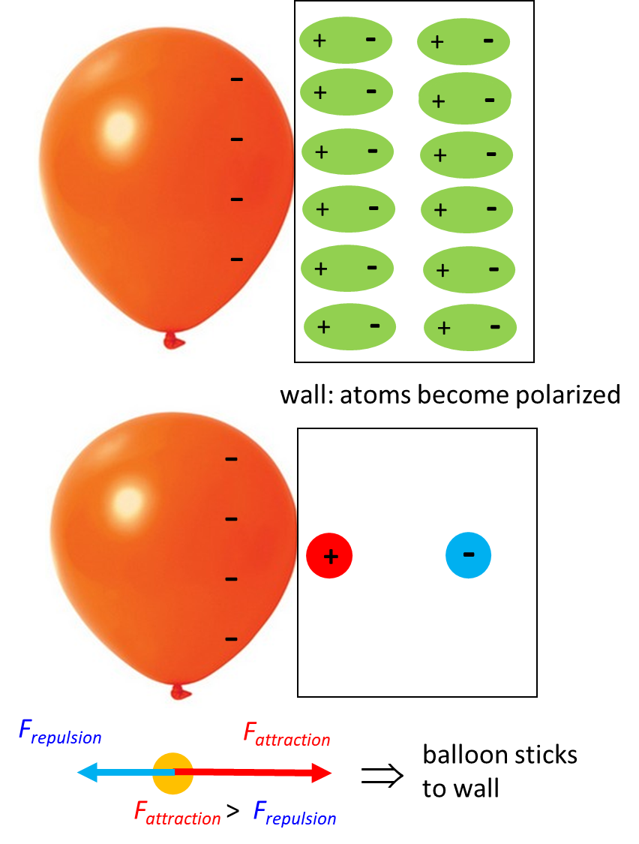

Fig. 10. The negatively charged balloon polarizes the atoms in the wall, resulting in a net attractive force between balloon and wall, so the balloon sticks.

[VISUAL PHYSICS ONLINE](http://www.physics.usyd.edu.au/teach_res/hsp/sp/spHome.htm)

If you have any feedback, comments, suggestions or corrections please email Ian Cooper

ian.cooper@sydney.edu.au

Ian Cooper School of Physics, University of Sydney

<http://www.physics.usyd.edu.au/teach_res/hsp/sp/spHome.htm>